**Store Management Software**

**Aim**

Aim of the software is to help shopkeepers so that they can manage their stores easily. With this software, they can place the customers’ orders for any item in the shop. They can also check the total money earned for any item and total purchases in the shop.

**Functionalities**

* Add, Update, Delete and view the customers in the shop (using CRUD operations).
* Add, Update, Delete and view the items in the shop (using CRUD operations).
* Update customers and items using stored procedures - `update_member` & `update_product`.
* Add the order by selecting customer and item already added.
* View all the purchases in the shop (using View and INNER Joins).
* Trigger to insert details in `orders_audit` after every order placed.
* Exporting Data to Excel in CSV
* List all Orders : All orders placed in the shop (using View - `order_view`).
* List all Products : All distinct item names in the product tables.
* Total money earned : Total of price of all orders (using SUM() aggregate function).
* Num of orders for product : No of orders for entered item name.
* Average Earn per item : using stored function - `average_earn_per_product()`.
* Products’ Order frequency : No of orders for every product.

**JAVA GUI**

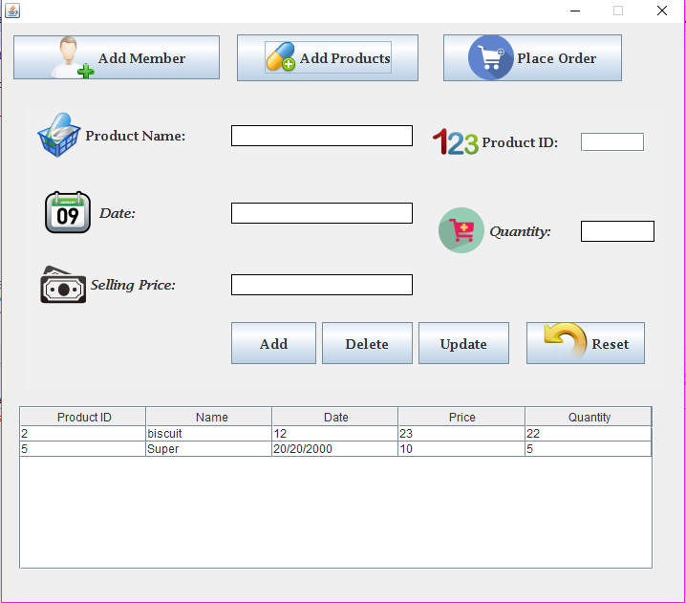Member Class Product Class

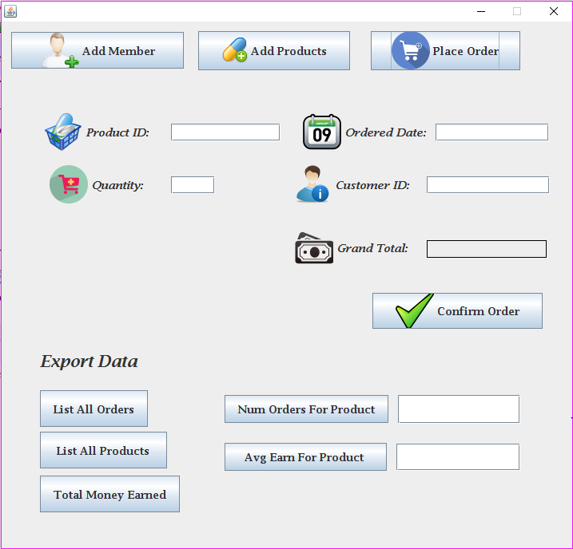Order Class (with Export CSV)

**Extra Features**

* Aggregate functions : COUNT, SUM, AVG
* GROUP BY clause to find out number of orders per product
* Index for productID and memberID in order table : member_index & prodnuct_index
* Stored procedure to update customer and product : `update_member` & `update_product`
* Stored function to find avg earn for item : average_earn_per_product()
* Trigger to add details in orders_audit after order is inserted in orders table.
* Export No of orders for every product in Excel : Excel chart to show products’ order distribution.

**Product Code**

Database Design

CRUD Operation

Insert & Delete using SQL statement

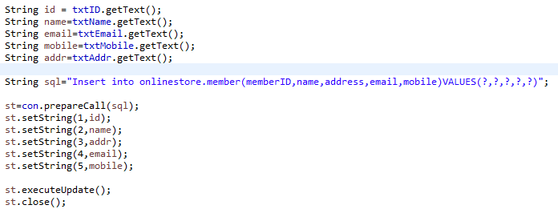

Update using Stored Procedure

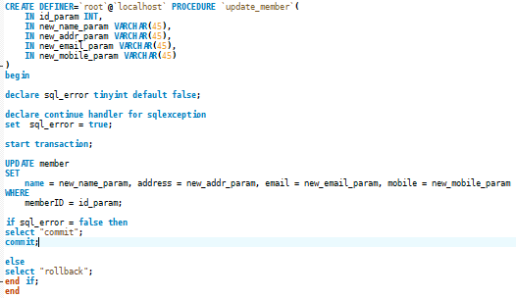

Stored Function to get average earn per product

View to get data using Inner Joins

This view will create virtual table with selected column from 3 different table

Trigger to add data in orders_audit

After every order is placed, trigger will automatically add order details in orders_audit

Excel Chart Features

Total Earning

Product Order Frequency

Gives the quantity of products ordered

**Conclusion**

This system makes it easy for shopkeepers to manage its customers and products. The shopkeeper can add the orders for customers with the quantity of desired product.

It also keeps the list of all orders and provide other features such as exporting no of orders per product to Excel.

Besides maintaining the list of customers and products, It also helps shopkeeper to find other details about orders like total money earned for all orders, which product made the most order, average money earned by every product in the shop etc.

**Learnings**

I learned about making interactive GUI in JAVA.

Implementation of triggers, stored functions and stored procedure in SQL.

Exporting data from SQL to Excel and present it in useful manner.